**BRIDGE TE AROHA: lovely place, lovely game ♠♥♦♣**

**Te Aroha News August 2025**

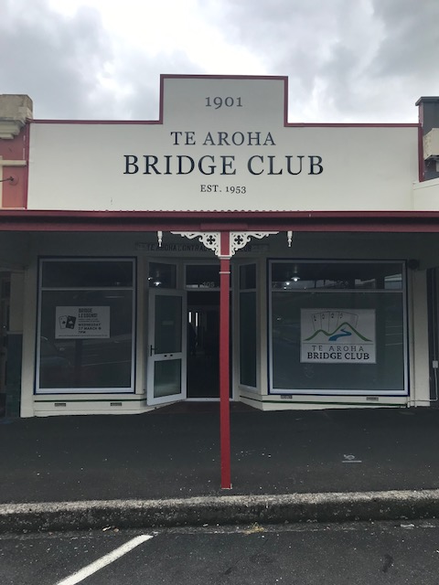 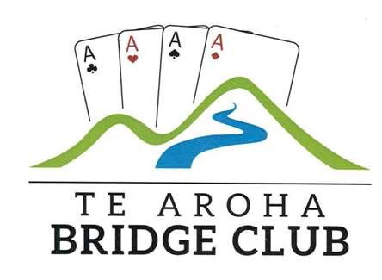

**A Good Day Out at Matamata**

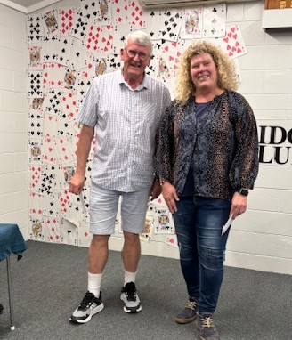 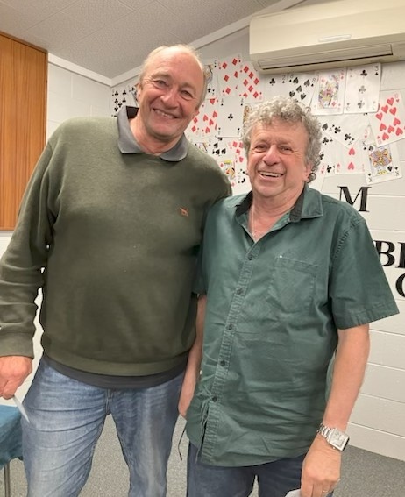

It was particularly for Anna who played the Matamata Swiss Pairs with the local club’s Noel Grigg. They were second with one of the six rounds to play and finished a very creditable 4th. Meanwhile, Tim and I were just in the prize money, in 8th place.

**A 70th Celebration**

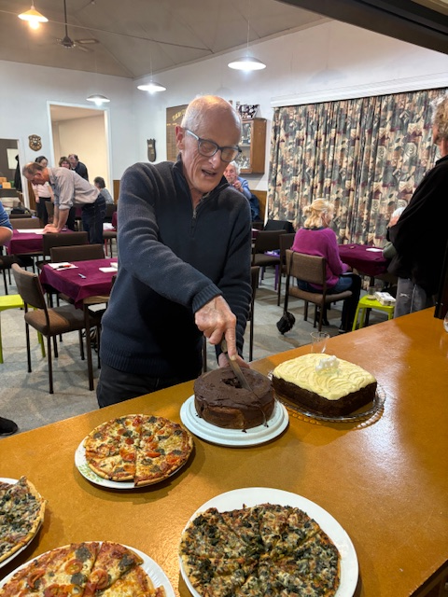

Mark the date in your diaries. I am sure Peter will not mind. July 29th is Peter TJ’s birthday and that date in 2025 was a rather special birthday. It was lovely that Peter celebrated his 70th birthday on that date at the club. We see him above cutting one of the two birthday cakes (alas, no matches meant no candles and thus no singing or blowing). There was plenty to eat that night with pizzas as well and just a little liquid to celebrate the occasion.

There was a rumour that Peter was trying to score his age at the club that evening. He did not quite achieve that but he and Judith did manage a very respectable 57.87%, 3rd off scratch that evening.

*and then*

**Just another Friday… or was it?**

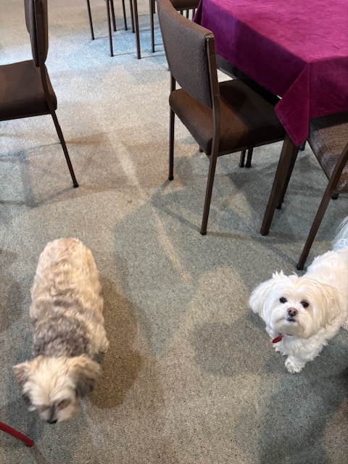

Yes, these two did not get a game though they were at the club on Friday 1st August during a neat session of bridge. They would have created a phantom had they played!   
Peter TJ was celebrating his long past birthday (yes, still) and most present joined in the celebration. When Laurie was seen taking in her favourite tipple, I had to join in (rude not to 😉) with a little spirit of my own. It was nice to see Gerry back. We washed it down with pizzas and cake…and then there were the dogs!

Jan’s Ace (”Acie”) is a regular (the whiter dog on the right) and was joined by Shirley Bailey’s Misty , a temporary resident with the Peters while Shirley swans it with the game in Africa’s game parks. She can rest assured that Misty is enjoying his holiday, especially on Fridays.

Then, there was the bridge…but you do not want to know about that, do you!

**If Bridge Players “ruled the world”.**

Maybe it would be a better place! We may not “rule the world” but we could very soon have representation in a small part of it. Those of you who keep abreast of local politics may well have seen that two of our Te Aroha regulars, Tyrel Glass and Paul Decker, are standing for Council in the upcoming local elections.

Both have already shown themselves as very valuable members of our club. We wish them well in striving to represent us in local politics.

Indeed, we could almost have a triumvirate as another standing is Greg Marshall, a very very close relation to Linda Merriman.

Good luck to you all.

**Anna and Richard in Oz**

Neither of us had been before to the 5 day long Coffs Harbour Bridge Congress though along with very affable teammates from the South Island, we headed there in mid-August. “There” is roughly half way down (or up, depending which way you look!) between Gold Coast and Sydney. A nice town, weather to match and an extremely well organised and friendly Congress at a seaside resort near the quite substantial town(thoroughly recommended).

We played in a 4 session Swiss Pairs finishing about one third of the way down a 114 pair field. However, our team won 7 out of 8 matches and finished 3rd out of 58 teams, less than 1 vp behind a team which included Matamata’s Kathy and Ken Yule, a very pleasing result for both pairs. This month’s tip comes from one of those winning matches.

**The Wisdom of Solomon**



**Bid to your maximum as soon as you can.**

That is the philosophy Anna adopted with her South hand below….and it certainly paid off.

|  |  |  |  |  |  |  |  |  |  |  |
| --- | --- | --- | --- | --- | --- | --- | --- | --- | --- | --- |
| West Deals E-W Vul | |  |  | | --- | --- | | ♠ | 10 9 | | ♥ | K Q 9 2 | | ♦ | 7 6 5 | | ♣ | Q 10 9 5 | | |
| |  |  |  |  |  |  |  |  |  |  | | --- | --- | --- | --- | --- | --- | --- | --- | --- | --- | | |  |  | | --- | --- | | ♠ | A Q 8 7 4 3 | | ♥ | A J 6 | | ♦ | J | | ♣ | 7 6 3 | |  | | |  |  |  | | --- | --- | --- | | N | | | | W |  | E | | S | | | | |  |  |  |  |  |  |  |  |  |  | | --- | --- | --- | --- | --- | --- | --- | --- | --- | --- | |  | |  |  | | --- | --- | | ♠ | K J 6 5 | | ♥ | 10 8 7 3 | | ♦ | 10 9 3 | | ♣ | A K | | |
|  | |  |  | | --- | --- | | ♠ | 2 | | ♥ | 5 4 | | ♦ | A K Q 8 4 2 | | ♣ | J 8 4 2 | | |

|  |  |  |  |
| --- | --- | --- | --- |
| West | North | East | South |
|  | *Richard* |  | *Anna* |
| 1 ♠ | Pass | 3 ♦ | 5 ♦ |
| 5 ♠ | All pass |  |  |

3D showed 4-card spade support and 10-11 hcp, Anna judged that her opponents were about to bid 4S. With the vulnerability in her favour, she jumped immediately to 5D giving her opponents a big problem. West decided to bid on to 5S.

I led a diamond and Anna won and switched to a heart. West ducked and I had a safe diamond exit and awaited my second heart trick to beat 5S by 1 trick. Meanwhile, our teammates played 4S making 10 tricks for a nice 12 imp gain. Best defence defeats 5Dx by 3 tricks though 2 down doubled (-300) is more likely.

Sometimes, opponents get such decisions right: sometimes as here, not. Here, they were more likely to get the decision right if you bid slowly to 5D. Anna’s immediate 5D was a great bid and deserved the reward it got.

**Closer to Home at Karapiro.**

Early August always means Cambridge 6’s time at its regular lovely home on the shores of Lake Karapiro. The weather matched the occasion, except for the 5 minutes when we went outside for some fresh air…”wet fresh air!”

32 teams of 6 players took part in Open, Intermediate and Junior grades. The all Te Aroha team did not star at the bridge table but finished a respectable 8th overall with Anna and I 6TH in the Open and June and Ross (Intermediate) and Katrina and Shirley Townsend (Junior) both finishing in the top half of their groups.

However, there was more than bridge to this occasion as the picture below depicts:

**Turkish Delight**

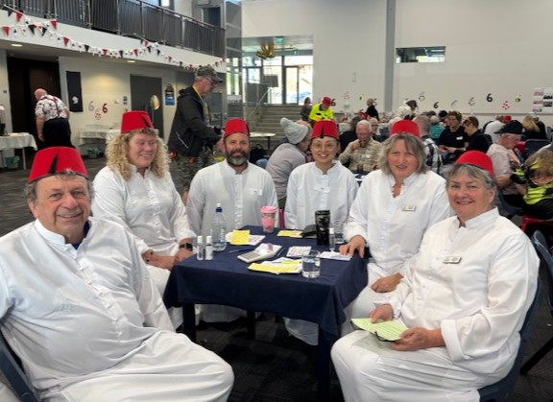

The theme for the dress-up was the letter “T” and hopefully these Turks fitted the bill. I do not think introductions are needed.

No prizes there either and not one successful raffle ticket amongst the many purchased at this table. (Our complaint was raised with the organisers who treated it with the disdain it deserved!)

However, when it came to the quiz, the Turks were on form and indeed no team answered more questions correctly than they did which meant first prize..well, a diluted one shared with two other teams. The team could not divide the two bottles of wine 6 ways. So, we hope some of you at the club enjoyed drinking them!

Peter Daffurn and Laurie also took part playing as part of the Thames Troopers team. You can see them in the photo below.

It was a most enjoyable day for bridge, socialising and just having a communal good time. Well done, Cambridge.

**Thames Troopers**

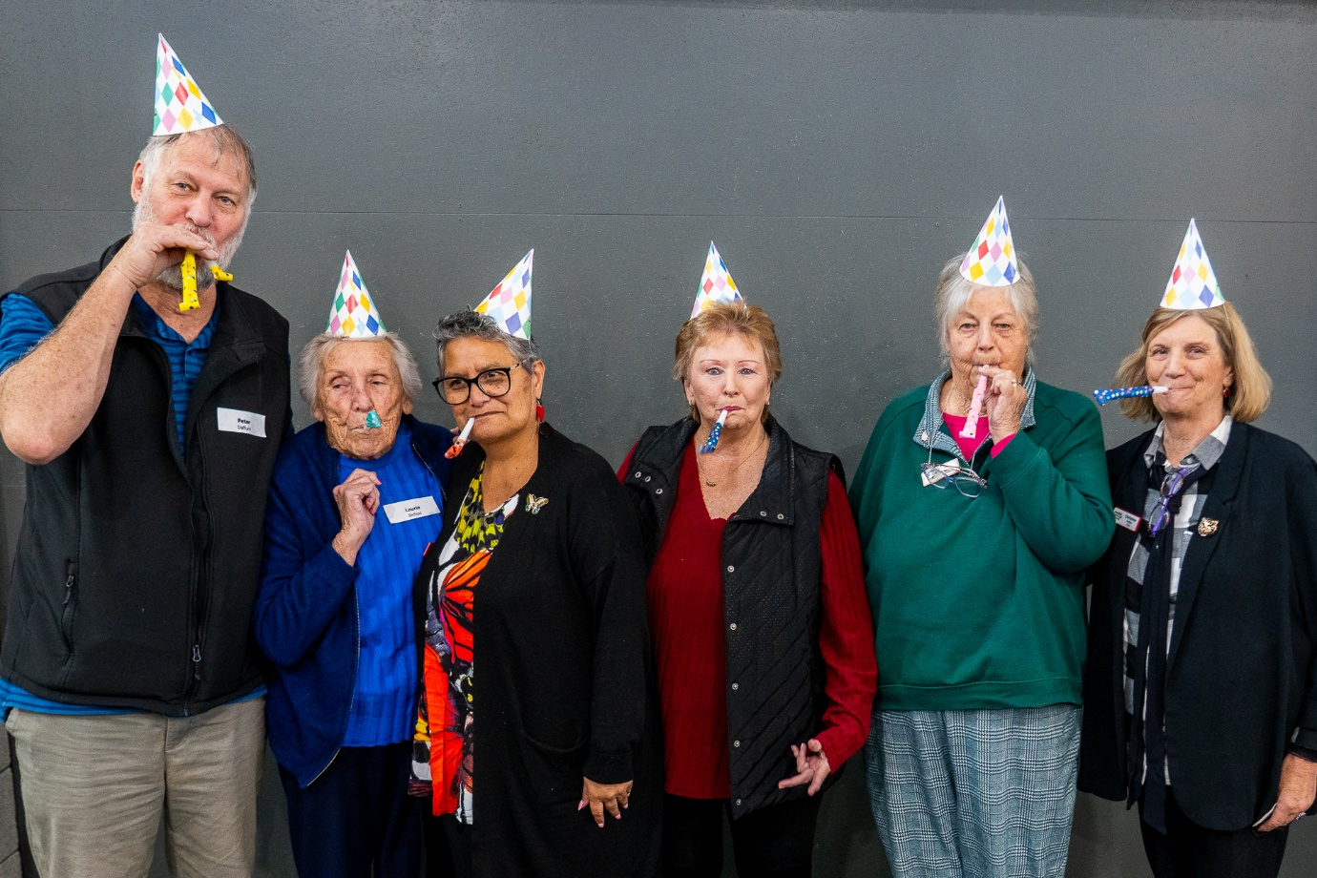

**Jo Mayall**

This annual competition between Katikati, Morrinsville, Waihi and Te Aroha takes place in our clubrooms on Sunday September 28th. We need two teams of 4 players with each player playing with the other three players in their team.

We have some names already on the wall at the club. If you are interested in playing, please either put your name on the list or see Rochelle. She and Peter Daffurn will ensure we have two teams ready to play that day.

**Comings and Goings**

That kind of sums up what is happening to quite a few club members at present.

Rochelle took off for West Virginia to settle her son, Fletcher, into university there. She was away just a week.

Victor has been on tour through Canada and Netherlands.

Joy and her husband, Gary, have had two wonderful weeks (at least I hope they were) cruising up the Danube and Rhine from Budapest to Amsterdam.

Anna Kalma will soon be heading for a few weeks to Europe.

So, indeed, will I, for the whole of September, to Ireland and England, catching up with family there.

This has three implications with respect to our Club.

Firstly, Tim will be ultra keen to extend his slim lead in the Slam Cup in my absence. 😊

Secondly, Jan will go into the final round of the Auckland Cup with a slim lead from Adri, Ross and Pat off scratch.

Thirdly, there will be no September club newsletter, unless someone steps up to write one.

So, in the meantime happy bridging and I look forward to seeing you all again in October.

**Last but by no means least**

Alan has had a different kind of trip to Melbourne recently. I spoke to him just prior to publication…and his news is good, very good. A successful operation. He hopes to be at bridge this Tuesday for the final round of the Auckland Cup. Then, just a small (who said that? 😉) glass of port. Great news.

*Richard*